**NAME** :- Manish Shashikant Jadhav

**UID** :- 2023301005.

**BRANCH** :- Comps -B. **BATCH:** B.

**EXPERIMENT 5: To perform join operation on data.**

**SUBJECT** :- DBMS (DATABASE MANAGEMENT SYSTEM)

create database elderlycare;

use elderlycare;

create table ngo(id int primary key, name varchar(20), address varchar(20));

insert into ngo(id, name, address) values (1, "swadesh", "Mahad"),

(2, "manish", "Andheri"), (3, "atharv", "bhoisar"), (4, "vishesh", "thane"), (5, "nipun", "jogeshwari"),

(6, "nishant", "kalyan"), (7, "krunal", "roha"), (8, "om", "panvel"), (9, "shubham", "karjat"),

(10, "samyak", "khopoli");

select * from ngo;

create table companion(id int primary key, name varchar(20), address varchar(20));

insert into companion(id, name, address) values (16, "swadesh", "Mahad"),

(2, "manish", "Andheri"), (3, "atharv", "bhoisar"), (4, "vishesh", "thane"), (5, "nipun", "jogeshwari"),

(6, "nishant", "kalyan"), (7, "krunal", "roha"), (88, "om", "panvel"), (9, "shubham", "karjat"),

(100, "samyak", "khopoli");

select * from companion;

create table companions(id int primary key, name varchar(20), address varchar(20));

insert into companions(id, name, address) values (16, "swadesh", "Mahad"),

(2, "manish", "Andheri"), (3, "atharv", "bhoisar"), (4, "vishesh", "thane");

create table ngo2(id int primary key, name varchar(20), address varchar(20));

insert into ngo2(id, name, address) values (1, "swadesh", "Mahad"),

(2, "manish", "Andheri");

1. **Equijoin:**

select ngo.id, ngo.name, companion.id, companion.address

from ngo, companion

where ngo.id=companion.id;

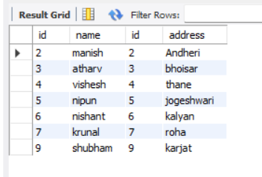

1. **Non-Equijoin:**

select ngo.id, ngo.name, companions.id, companions.address

from ngo, companions

where ngo.id<companions.id;

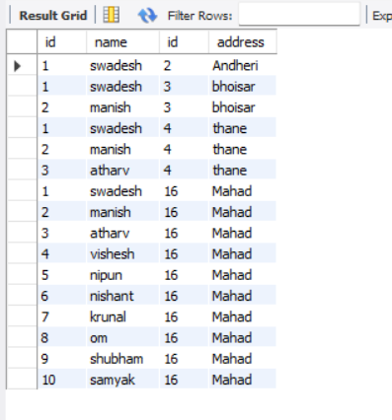

1. **Selfjoin:**

select ngo.name as name1, companion.name as name2, ngo.address

from ngo,companion

where ngo.id<>companion.id

and ngo.address = companion.address

order by ngo.address;

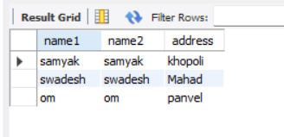

1. **Cross Join:**

select ngo2.name, companions2.address

from ngo2

cross join companions2;

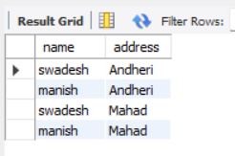

1. **Outer Join:**
2. **Left Outer Join:**

select ngo.name, companion.id

from ngo

left outer join companion

on

ngo.id=companion.id

order by ngo.name;

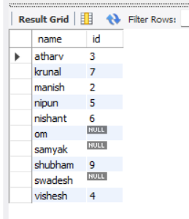

1. **Right Outer Join:**

select ngo.name, companion.id

from ngo

right outer join companion

on

ngo.id=companion.id

order by ngo.id;

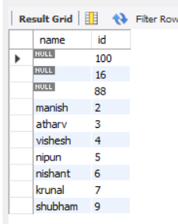

1. **Full Outer Join:**

select ngo.name, companion.id

from ngo

left outer join companion

on

ngo.id=companion.id

union

select ngo.name, companion.id

from ngo

right outer join companion

on

ngo.id=companion.id;

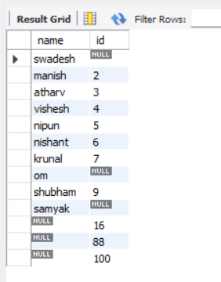

**Conclusion:** Hence by completing this experiment I came to know about how to implement Join operations.